Case 1: Sales Performance Analysis
Company Background
TechSupply Co. is a regional distributor that sells electronics, office supplies, and office furniture to both retail and business customers. Management wants to better understand sales trends, customer purchasing behavior, and regional performance to improve future sales strategies.
You have been hired as a junior data analyst to explore the sales dataset and provide insights. Your task is to use Excel filtering and sorting tools to answer business questions and provide recommendations.
Dataset: use the techsupply_dataset.xlsx
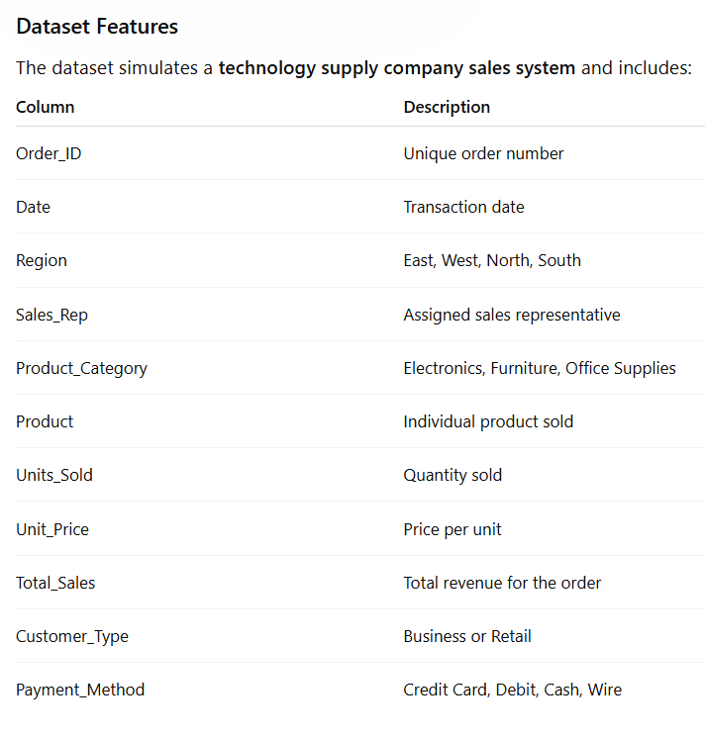

Complete the following 5 tasks.
REGIONAL PERFORMANCE ANALYSIS
Task 1: Use filters to explore sales by region.
- Filter by Region = East
- Sort Total_Sales from Largest to Smallest
Questions:
- What is the largest sale in the East region?
- The largest sale in the East Region is 52950

- Which product category appears most frequently?
- The product category that appears most frequently is Electronics.

- Which sales representative appears most often?
- Brown and Johnson are the ones that appear most often
CUSTOMER BEHAVIOR ANALYSIS
Task 2: Filter by
- Customer_Type = Business
Questions
- Which product category do business customers purchase most often?
- Office supplies are the most often purchased product category for business customers.

- What is the largest business transaction?
- The largest transaction was 63646.2

- Which sales rep handles the most business orders?
- Brown and Garcia handled the same number of orders (25 each).
PRODUCT PERFORMANCE
Task 3: Use filters to analyze Product_Category.
Analyze each category separately:
- Electronics
- Furniture
- Office Supplies
Questions
- Which category appears to generate the highest total sales?
- Electronics
- Which specific product appears most frequently?

- Which category tends to have the largest individual transactions?
PAYMENT PATTERN ANALYSIS
Task 4: Filter by Payment_Method
Analyze:
- Credit Card
- Debit
- Cash
- Wire
Questions
- Which payment method is used most frequently?
- Credit Card

- Do business customers prefer a specific payment type?
- Business customers prefer using Debit

- Which payment type is associated with larger purchases?
- Wire
TOP SALES REPRESENTATIVES
Task 5: Sort by:
- Sales_Rep
- Total_Sales(Largset > Smallest)
Questions
- Which sales rep appears to handle high-value transactions?
- Garcia appears to have handled high-value transactions.

- Which rep appears most frequently in the dataset?
- Brown

- Which region do they appear to sell in most often?
- The East
ANALYST RECOMMENDATION
Imagine you are presenting your findings to management.
Answer the following:
- Which region appears to be the strongest market?
- The East seems to be the strongest market

- Which product category should the company promote more?
- The company should promote more Office Supplies

- Are business customers or retail customers more valuable?
- Business customers are more valuable.

- What two recommendations would you give the sales manager?
- Create ads/promote to the east for more office supplies

- Make a website with online ordering available so people can order online and use a credit or debit card to pay.
Bonus
Build
- Bar Chart – Sales by Product Category
- Pie Chart – Customer Type Distribution
- Column Chart – Sales by Region
What story does the data tell?

